Blessing-Rieman College of Nursing and Health Sciences Institutional Review Board (IRB)
  - Handbook (2026)

The Handbook provides the IRB’s policies and procedures for approving and monitoring research involving human participants and/or their records. These policies and procedures are in accordance with federal regulations governing IRBs registered with the Office of Human Research Protection (OHRP).

Table of Contents

General Information 1
Source of Policies and Procedures 1
Purpose of an IRB 1
Scope of an IRB 1
Flow Chart to Determine if IRB Approval is Required 2
Responsibility of the Researcher 2
Prior IRB Approval Needed to Implement Research 2
Sponsoring Institution 2
Mission of the IRB 3
Types of Review 3
Full Review 3
Expedited and Exempt Reviews 3
Expedited Review 3
Flow Charts to Determine Eligibility for an Expedited Review 4-6
Exempt Review 6
Flow Charts to Determine Eligibility or an Exempt Review 7-8
Consent 9
Informed Consent 9
Flow Chart to Determine if Written Inform Consent is Required 9
Informed Consent Process 9
Informed Consent Form 10
Assent of Minors 10
Implied Consent 10
Flow Chart to Determine Eligibility for Implied Consent 11
Implied Consent Process 11
Guiding Principles and Criteria Used by the IRB to Approve Studies 11
Criteria 11
Guiding Principles 12
Submitting a Study for IRB Review 12
Protection of Human Participants Training 12
IRB Decisions 13
Approval 13
Deferred Decision 13
Disapproval 13
Suspension or Termination of Approval 13
IRB Notifications 14
Notification of IRB Decisions 14
Notification at End of Study/Extension of Timeline for Full and Expedited Reviews 14
PI Reporting to the IRB 14
Interim Reports 14
Change in Protocol 14
Reporting Adverse Effects 14
Deviations from Protocol 14
Studies Involving Deception 15
Debriefing 15
Research Using Health-related Data 15
Research Involving Other IRBs 15
Researchers Affiliated with the College 15
Non-college Affiliated Researchers 15
Appendix 1: Definitions 17
Appendix 2: Categories of Potential Risks to Participants 19
Appendix 3: Assent from Minors 20
Appendix 4: Guiding Principles 21
Appendix 5: Operations of the IRB 22

General Information

Source of Policies and Procedures
The following federal regulations guide the content of this Handbook.
TITLE 45- PUBLIC WELFARE
DEPARTMENT OF HEALTH AND HUMAN SERVICES (HHS)
PART 46- PROTECTION OF HUMAN SUBJECTS
Revised January 15, 2009
Effective July 14, 2009
Revised January 19, 2017
Effective January 23, 2019
Up-to-date as of January 22, 2026

Only research involving human subjects funded by the government are covered by HHS regulations. Institutions may choose to follow HHS regulatory procedures when not required to do so. Blessing-Rieman College of Nursing and Health Sciences (BRCN) has chosen to follow HHS regulations governing research.

Purpose of an IRB
The purpose of an IRB is to protect the rights and welfare of human subjects (and animals if applicable). An IRB carries out its purpose by approving only those studies that meet all the requirements for the protection of human subjects (participants) and their rights, using an independent process that verifies studies protect participants.

Scope of an IRB
An IRB only reviews and approves research studies that involve participants and animals. IRBs do not review and approve quality improvement (QI) activities and research that does not involve humans and animals. QI, however, becomes research needing IRB approval when interventions and/or interactions involve direct contact with individuals in order to systematically test or evaluate the effectiveness of a specific intervention or interaction.

The following flow chart will help determine if IRB approval is required for a study.
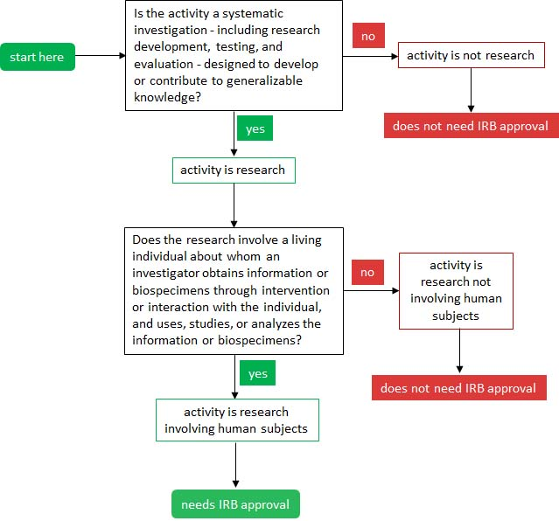

Definitions for research, human subject (participant), information, biospecimen, intervention, interaction, and quality assurance are in Appendix 1.

Responsibility of the Researcher
The researcher (principal investigator) is responsible for following IRB policies and procedures when seeking approval for a proposed study, and during the conduct of the study after it has been approved by the IRB. The principal investigator (PI) is expected to provide adequate protection of the privacy, safety, health, and welfare of the study’s participants. When the study involves a research team, the PI is responsible for all team members’ actions with protecting the privacy, safety, health, and welfare of the study’s participants. By definition, the research team is a group of individuals who have a significant role with recruiting and selecting participants, collecting data, analyzing data, and/or drawing conclusions from findings. A research team does not include the student’s faculty advisor when the study is a project, thesis, or dissertation.

Prior IRB Approval Needed to Implement Research
PIs must obtain IRB approval before they implement their studies. Recruitment of participants and data collection begin only after receiving notification from the IRB that the study was approved. Notification is a letter sent to the PI.

Sponsoring Institution
IRBs are sponsored by institutions conducting human subject research to ensure compliance with federal regulations that govern the protection of participants. Institutions include colleges and universities, hospitals, medical centers, non-profit research organizations, and for-profit companies such as pharmaceutical/device firms. In the United States, independent commercial IRBs also exist to review specific studies. The IRB at BRCN is sponsored by BRCN. For the rest of the handbook, IRB refers to the IRB at BRCN.

Mission of the IRB
The mission of the IRB is to support research and scholarship that is beneficial to BRCN’s constituents and the community by approving only those studies that demonstrate ethical treatment and protection of human and animal research participants and/or records.

The IRB’s first priority is to review research studies conducted by BRCN students and employees. The second priority is to review research studies conducted within the Blessing Health System. The third priority is to review studies within the community by request of another institution, agency, or organization. The IRB does not review clinical trials, FDA-related research studies, and certain studies involving vulnerable populations, minors, or more than minimal risk. The IRB has the option to refuse the review of research that does not fit the expertise of its members, or will review such studies with consultation from experts in the area of the research being reviewed. To learn more about the IRB at BRCN, see Appendix 5.

Types of Review

There are three types of review. They are full, expedited, and exempt. PIs request the type of review as part of the IRB application and the IRB Chair validates the request is appropriate based on the study or project’s protocol and the degree to which the protocol poses risks to participants. Risks are the possibilities of exposure to physical, psychological, or social harm as a direct consequence of participation in a research study and its related activities. See Appendix 2 for descriptions of the categories of possible risks to participants inherent to a research study or project.

Full Review
A full review is required for research that poses greater than minimal risk, or involves minors or vulnerable populations. The entire IRB membership reviews the application. Depending on the time between submitting the application and all members of the IRB reviewing it, the length of time for a response may be 30 days or more. See Appendix 1 for the definition of greater than minimal risk and vulnerable population.

Expedited and Exempt Reviews
The expedited and exempt reviews are for studies that present no more than minimal risk to participants and fit certain categories of research. See Appendix 1 for the definitions of minimal risk and greater than minimal risk.

Expedited Review
Expedited reviews require three IRB members to review the application because there are possibilities of risks, although minimal, given the nature of the research. Depending on the time between submitting the application and the three members reviewing it, the length of time for a response is two to three weeks. For a project or study to be eligible for an expedited review, it must fit one of eight categories. See the following flow charts to determine if a project or study is eligible for an expedited review under Categories 1 – 7. For Categories 8 and 9, the IRB uses an expedited or exempt review when it determines the research involves no greater than minimal risk and no additional risks have been identified. Most often, reviews of continuing research involve changes in protocol.
Category 1: Clinical Studies of Marketed Drugs or Medical Devices
Does your study or project fit this category? To find out, answer the following questions.

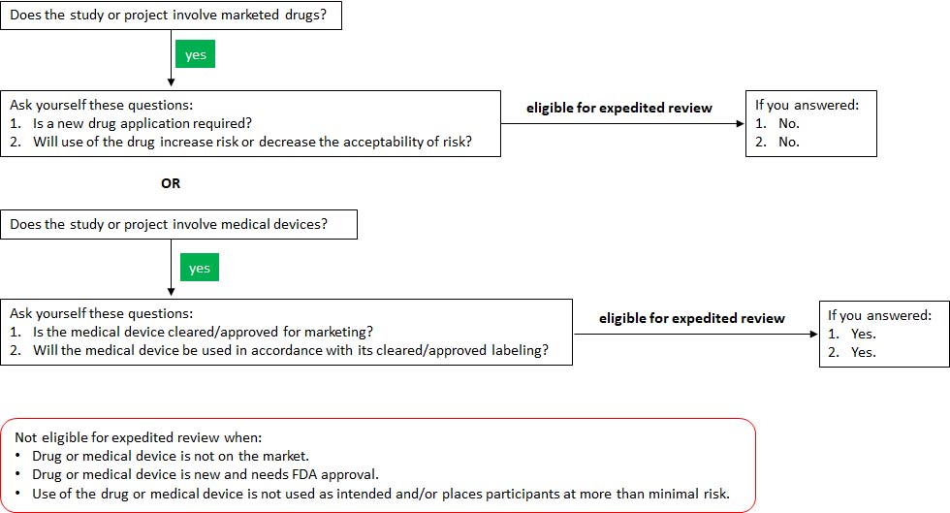

Category 2: Collection of Blood Samples
Does your study or project fit this category? To find out, answer the following questions.

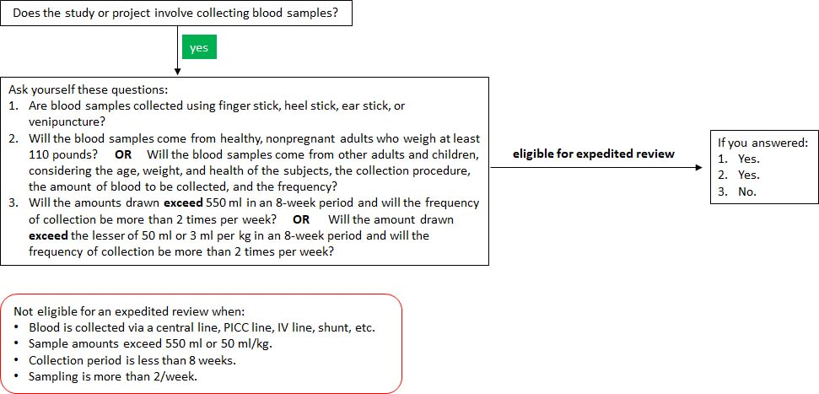

Category 3: Collection of Biological Specimens
Does your study or project fit this category? To find out, answer the following questions.

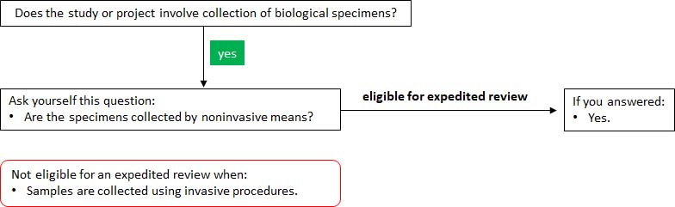

Category 4: Use of Noninvasive Procedures
Does your study or project fit this category? To find out, answer the following questions.

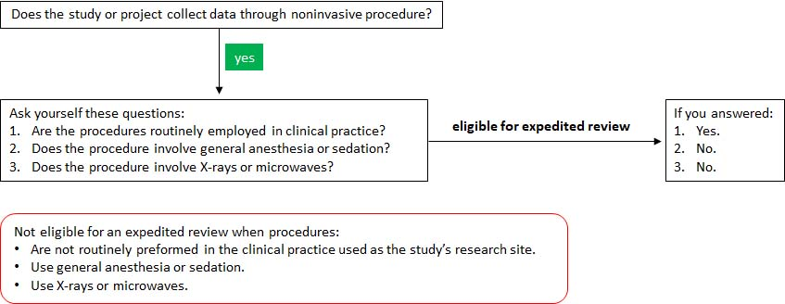

Category 5. Use of Data Collected for Non-Research Purposes
Does your study or project fit this category? To find out, answer the following questions.

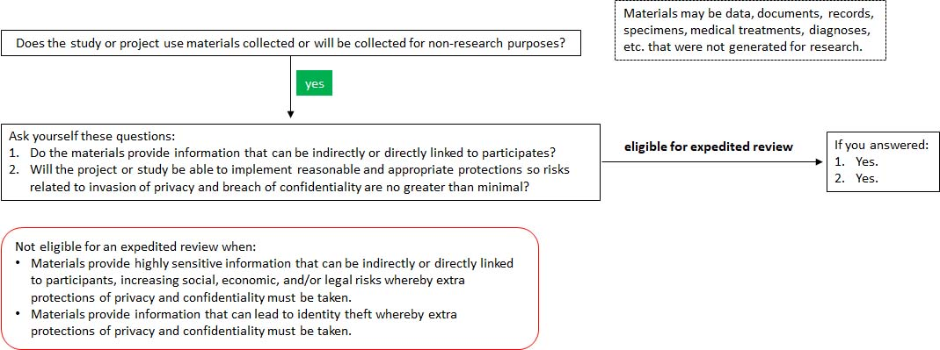

Category 6: Collection of Data Using Media
Does your study or project fit this category? To find out, answer the following questions.

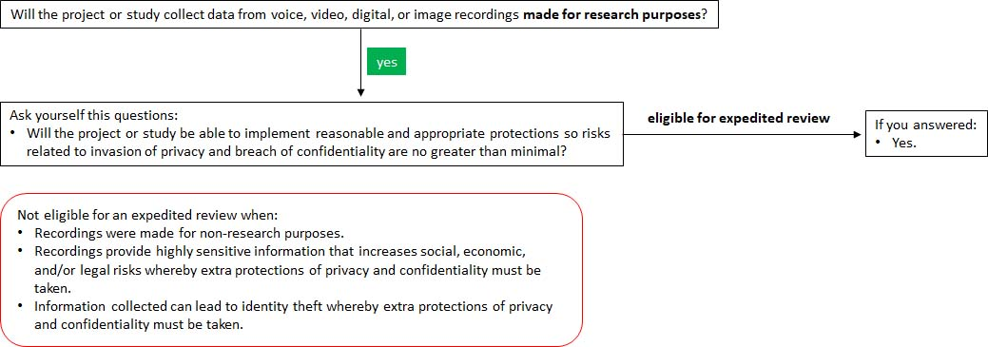

Category 7: Research Involving Interaction with Participants
Does your study or project fit this category? To find out, answer the following questions.

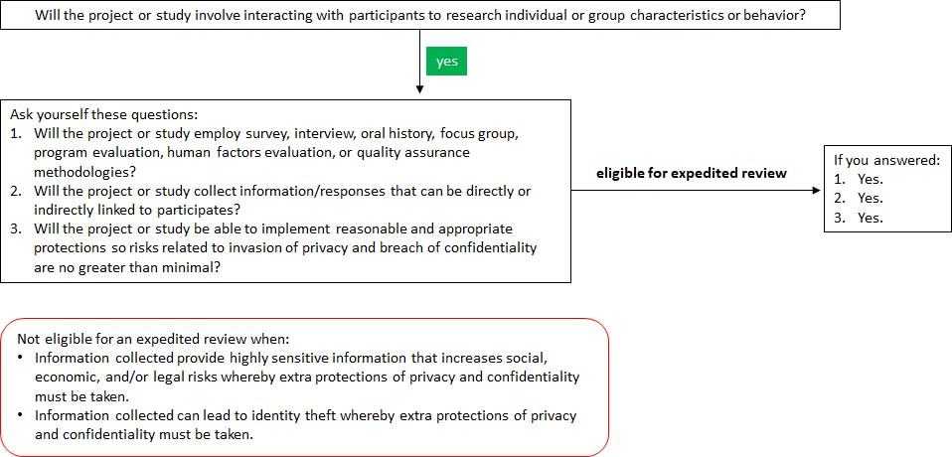

Category 8: Continuing Research on Closed Studies
This category is for continuing review of research previously approved by the IRB where the research is permanently closed to the enrollment of new subjects, all subjects have completed all research-related interventions, and the research remains active only for long-term follow-up of subjects. This category also applies to research where no subjects have been enrolled and no additional risks have been identified or where the remaining research activities are limited to data analysis.

Category 9: Continuing Research
This category is for continuing review of research, not conducted under an investigational new drug application or investigational device exemption where categories two (2) through eight (8) do not apply but the IRB has determined and documented that the research involves no greater than minimal
risk and no additional risks have been identified.

Exempt Reviews
Exempt reviews only need one IRB member (usually the Chair) to review ensure the study provides adequate protection of the privacy, safety, health, and welfare of the study’s participants. Depending on the time between submitting the application and the IRB member reviewing it, the length of time for a response is within two weeks. For a project or study to be eligible for an exempt review, it must fit one of six categories. See the following flow charts to determine if a project or study is eligible for an exempt review under Categories 1 – 6.

Category 1: Educational Research
Does your study or project fit this category? To find out, answer the following questions.

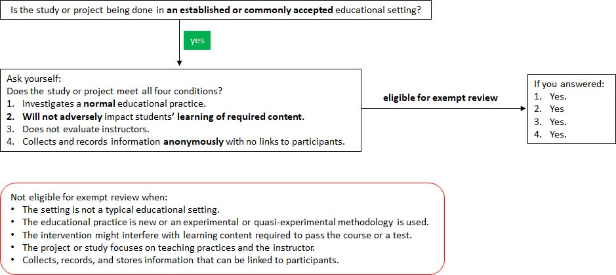

Category 2: Surveys, Interview, Educational Tests, and Public Observations
Does your study or project fit this category? To find out, answer the following questions.

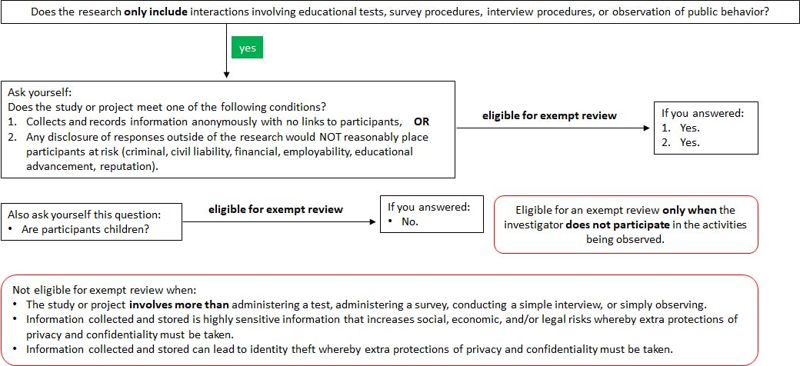

Category 3: Benign Behavioral Interventions
Does your study or project fit this category? To find out, answer the following questions.

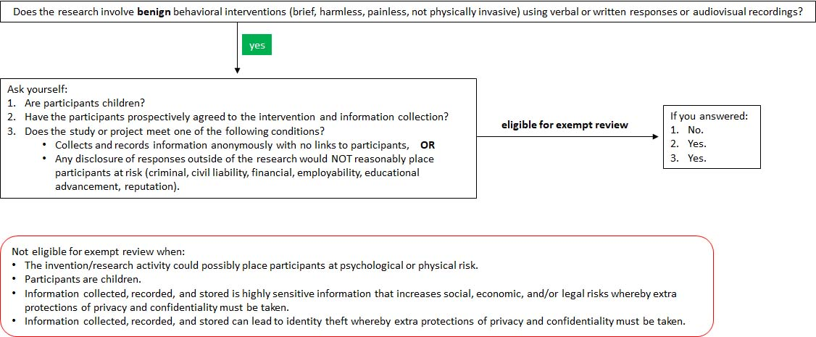

Category 4: Secondary Research Uses of Identifiable Private Information or Identifiable Biospecimens
Does your study or project fit this category? To find out, answer the following questions.

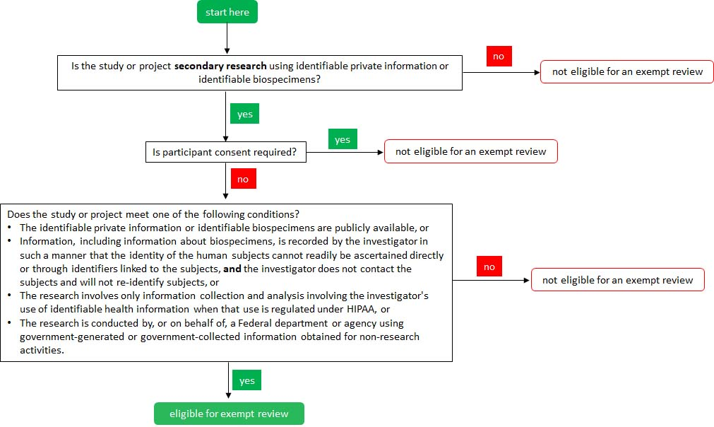

Category 5: Federal Research or Demonstration Projects
Does your study or project fit this category? To find out, answer the following questions.

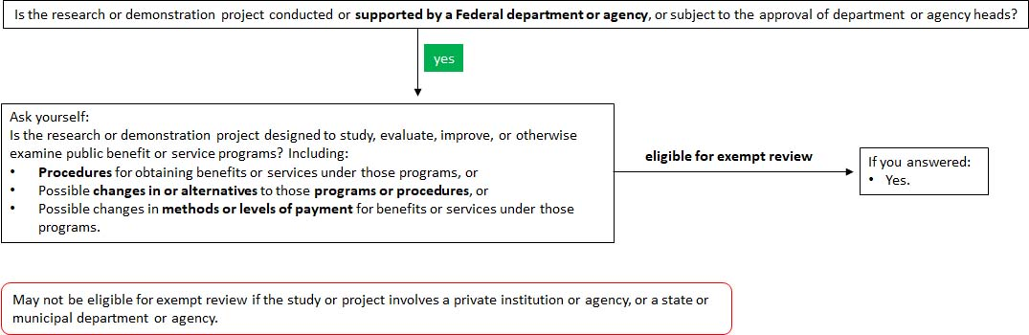

Category 6: Taste and Food Quality Evaluation Studies
Does your study or project fit this category? To find out, answer the following questions.

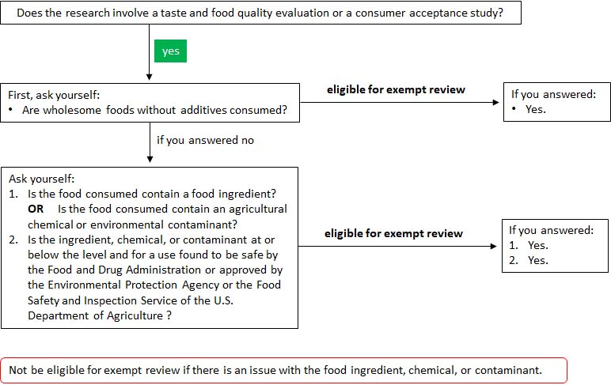

Consent

Participation in all types of research is voluntary and therefore, all participants must consent to participate in a study or project. Consent is the act of voluntarily and willfully agreeing in response to another person's proposition. In this case, the proposition is the request to being a research participant/subject. Consent is either informed or implied.

The PI identifies the type of consent as part of the IRB application and the IRB Chair validates the type of consent is appropriate given the nature and inherent risks of the research study or project. Although the PI identifies the type of consent, the IRB may ask the PI to amend the type of consent, the consent process, content of the contest form, information provided to prospective participants, and/or the studies recruitment of volunteers.

Informed Consent
Informed consent is a voluntary, collaborative process where the individual agrees to participate in a research study after comprehensively understanding all relevant risks, benefits, and alternatives. It requires a documented agreement signed by the participant after receiving full information about the risks and benefits of participation. To help determine if this type of consent is required, see the flow chart below.

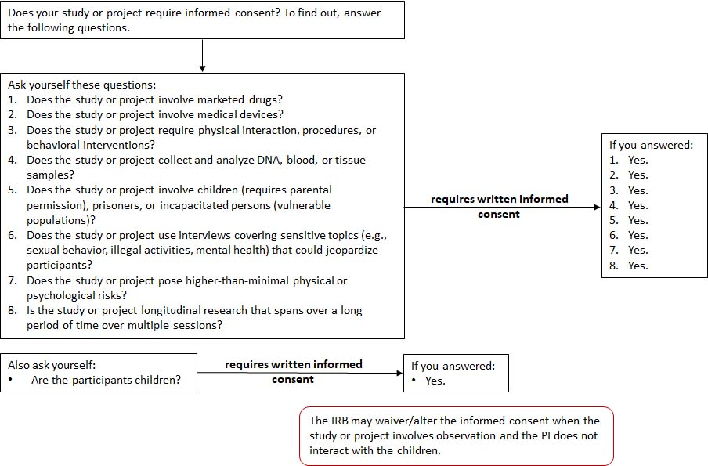

Informed Consent Process
IRB approval of the study’s process for obtaining informed consent is based on the protocol adequately explaining how potential participants are provided:
- All pertinent information about the study.
- The opportunity to ask questions.
- Sufficient time to decide about participation.
- Information that participation is voluntary, can withdraw at any time without consequences, and no penalties for refusing to participate.
- The steps to maintain privacy and confidentiality when obtaining and storing participants’ signed informed consent documents.

Informed Consent Form
Informed consent must be documented by the use of a written consent form that contains all of the required basic elements of informed consent and has been signed by the participants or the participants' legally authorized representatives. A copy of the informed consent form must be provided to all participants.

IRB approval of the study’s informed consent form is based on the following statements, explanations, and descriptions are in the document:
- The study involves research and the purposes of the research.
- Expected duration of participation.
- The procedures to be followed, and identification of any procedures which are experimental.
- Any reasonably foreseeable risks or discomforts to the participant.
- Any benefits to the participant or to others which may reasonably be expected from the research.
- The extent to which confidentiality of records/documents/data identifying the participant will be maintained.
- Contact information for answers to pertinent questions about the research and research participants' rights, and who to contact in the event of a research-related injury to the participant.
- Participation is voluntary, refusal to participate involves no penalty or loss of benefits to which the participant is otherwise entitled, and the participant may discontinue participation at any time without penalty or loss of benefits to which the subject is otherwise entitled.
- Language is understandable to participants. Understandable language is clear and unambiguous, including an appropriate reading level for participants and appropriate explanations for all technical terms.
- For research involving more than minimal risk, an explanation as to whether any compensation and an explanation as to whether any medical treatments are available if injury occurs and, if so, what they consist of, or where further information may be obtained.

PIs using human participants whereby a signed informed consent is required must keep all consent forms in a secured location. The length of time that consent forms must be kept is based on the institution’s research or records policy. When such a policy does not exist, the IRB recommends that signed informed consent forms are kept for five (5) years after completion of the research project.

Assent of Minors
Participants who are minors (under the age of 18 and not legally emancipated) cannot give their informed consent to participate in a study. Therefore, they must give assent to participate in research. Assent is defined as “a child’s affirmative agreement to participate in research.” Assent from a minor must be obtained in a language that is understandable to him/her and requires using an age-appropriate assent form. To learn more about assent from minors, see Appendix 3.

Implied Consent
The IRB may waive or alter the requirement for PIs to obtain signed, written informed consent from participants. When the waiver or alteration is granted, consent is implied. With implied consent, the investigator can reasonably conclude - infer – from the individual’s actions that agreement to participate was given. Implied consent may be given in the following manner:
- Behavioral/action-based consent: The participant acts in a way that implies agreement to participate, such as returning a completed survey, clicking "next" on an online survey, or voluntarily participating in a focus group after hearing the study details.
- Passive consent: The participant does not object or opt-out after being informed about the study.
- Verbal consent: The participant verbally agrees after receiving an explanation about the study.

To help determine if a study or project is eligible for implied consent, see the chart below.

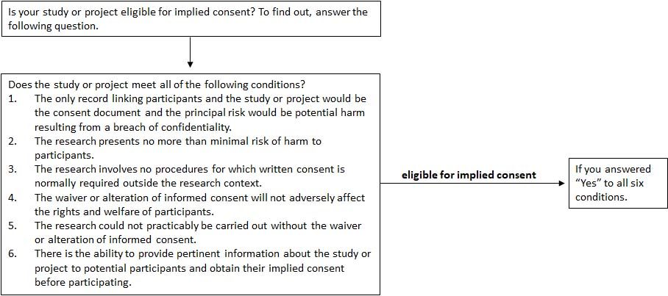

Implied Consent Process
Although no signature is collected, information must still be provided to potential participants using methods such as an information sheet, email with a link to a survey, or cover page to a survey. The IRB approves the process to obtain implied consent when the protocol adequately explains how information about the study will be given to potential participants and how participates will give implied consent. The information provided to potential participants must cover:
- Statement of Research: Clearly states the activity is a research study.
- Purpose and Procedures: An explanation of the research purpose, expected duration, and a description of procedures.
- Voluntary Nature: A statement that participation is voluntary and they may withdraw at any time.
- Risks and Benefits: A description of any foreseeable risks, discomforts, or benefits.
- Confidentiality: A description of how, or if, data privacy/anonymity will be maintained.
- Contact Information: Information on whom to contact with questions about the research.

Guiding Principles and Criteria Used by the IRB to Approve Studies

Criteria
The IRB approves a research study or project when the following criteria are met:
- Risks to participants are minimized by using procedures that are consistent with sound research design and do not unnecessarily expose participants to risk.
- Risks to participants are reasonable in relation to anticipated benefits, if any for the participants, and the importance of the knowledge that may reasonably be expected to result from the research.
- Selection of participants is equitable.
- Informed consent will be sought from each prospective participant or the participant's legally authorized representative.
- Informed consent will be appropriately documented or appropriately waived.
- The protocol makes adequate provision for monitoring the data collected to ensure the safety of participants.
- There are adequate provisions to protect the privacy of participants and to maintain the confidentiality of data.
- When appropriate, broad consent for storage, maintenance, and secondary research use of identifiable private information or identifiable biospecimens is obtained; and there are adequate provisions to protect the privacy of participants and to maintain the confidentiality of data.
- When some or all of the participants are likely to be vulnerable to coercion or undue influence, the protocol includes additional safeguards to protect the rights and welfare of these participants.

Guiding Principles
The following principles are the foundation for the criteria to approve a research study or project. Researchers are expected to incorporate these principles into their protocols, treatment of participants, recruitment of participants, and informed consent. The IRB approves only those research studies and projects that incorporate these principles. The principles are:
- Maintaining participant autonomy.
- Maintaining the safety of participants.
- Promoting benefits to the participants and the larger community.
- Conducting research in a fair and equitable manner.
- Honoring commitments made to participants in a study.

See Appendix 4 for the descriptions of each guiding principle.

Submitting a Study for IRB Review

Submitting a study for review is electronic and the application is on the BRCN Library’s website under Online Research. Click the Institutional Review Board Link to access the IRB’s webpage. Click the Forms link and then download the IRB Application. The application includes information about the PI, research team if there is one, and the study’s plan for conducting the research (protocol). The PI is responsible for completing the application, attaching the necessary documents, and submitting it as an email attachment to the IRB at irb@brcn.edu.

The IRB relies on the protocol being an in-depth description of the research from which to determine level of risk and ascertain that adequate provisions to protect participants’ rights and welfare from these risks are in place. Therefore, the application must provide enough details about protecting participants, risks inherent to the study, benefits from researching the topic, and methodology. Applications submitted with excessive grammatical errors, unclear writing, or without needed information will be returned without review.

Protection of Human Participants Training
The PI and all members of the research team must successfully complete training in the protection of human research participants. Proof of this training is the submission of a certificate indicating completion of training. The certificate(s) is submitted with each and all applications for an IRB review because the IRB does not file and track certificates for individual researchers.

Training is online and a link to this training is available on BRCN’s library website under Online Research. Click the Institutional Review Board link to access the IRB’s webpage and click the Protecting Human Research Participants link. The link goes to the Protecting Human Research Participants (PHRP) Online Training site. Remember to print or download the certificate as proof of completing the course.

IRB Decisions

The IRB will make one of three decisions after reviewing a proposed study. The decisions are approval, deferred decision, and disapproval.

Approval
The IRB approves the study as proposed, granting permission to proceed with the study. The expectation is that the PI and any research team implement the study as described in the application for IRB review.

Deferred Decision
Additional information is needed before the IRB can make a decision about approving the study. Decisions to defer approval occur when the IRB has concerns about how the study is or is not protecting the rights and welfare of its research participants. To help the IRB make a decision, the PI submits a revised proposal or attends an IRB meeting in order to provide IRB members with the necessary information to make a fully informed decision about approving the study’s protocols.

Disapproval
The IRB does not approve the study because the IRB determined that its protocol did not adequately
protect the research participants’ rights and welfare. The IRB’s written notification of the disapproval includes the reasons for the decision and gives the PI/research team an opportunity to revise and resubmit an IRB application that incorporates all the changes required for approval by the IRB.

Suspension or Termination of Approval
The IRB has the authority to suspend or terminate its approval of research that is:
- Not conducted in accordance with the IRB's requirements.
- Associated with unexpected serious harm to participants.
- Delinquent in the submission of materials required by the IRB for purposes of granting extensions.

The IRB notifies PIs in writing of the suspension or termination of their research. The IRB also notifies the College’s President/CEO as well as other parties that need to be aware of the study’s suspension or termination. The Secretary of the Department of Health and Human Services is notified in the case of a federal grant or grant application. Notification includes the reasons for the suspension or termination. PIs/research teams cannot collect data, in any form, when their studies have been suspended or terminated. Any data collected during the suspension or after termination must be discarded and not be used in any research capacity.

IRB Notifications

Notification of IRB Decisions
The Chair of the IRB notifies the PI of the IRB's decision in regards to approving the research. Notification is a letter sent as an email attachment. Approval letters serve as the IRB’s letter of certification that can be sent to any entity requesting proof of the research was approved by the IRB.

Notification at End of Study/Extension of Timeline for Full and Expedited Reviews
The Chair of the IRB notifies the PI when the timeline for collecting data is over and therefore the study is done from the IRB’s point of view. The PI/research team can no longer collect data unless more time is requested of the IRB. A request is made by completing a Timeline Extension form. The form is on the College library’s website under Online Research. Click the Institutional Review Board Link to access the IRB’s webpage. Click the Forms link and then download the Timeline Extension form. Follow the directions and submit it as an email attachment to irb@brcn.edu.

PI Reporting to the IRB

The PI is responsible for completing the following reports during the study.

Interim Reports
The IRB may ask the PI to submit a progress report when the study poses more than minimal risk and/or is longitudinal in nature. The purpose of this report is to assure that the rights and welfare of the study’s participants continue to be protected. The PI is expected to submit reports according to the timetable established by the IRB.

Change in Protocol
PIs must obtain IRB approval for any proposed changes to approved protocols. This approval must be done before any changes are implemented. However, changes that are necessary to eliminate immediate hazards can be implemented without prior IRB approval. The Request for Change in Protocol form is on the IRB’s webpage.

Reporting Adverse Effects
PIs are required to inform the IRB of adverse events within 24 hours after the event occurred or is discovered. Notification is done by submitting the Adverse Event form that is on the IRB’s webpage.
The Chair of the IRB reports all adverse effects to the IRB membership as well as the College’s
President/CEO and any other entities needing to know that the event occurred. Action taken depends on the circumstances of the adverse effect.

Deviations from Protocol
PIs are required to report any deviations from the approved protocol. This reporting may be done by anyone who is aware of the deviation. Reporting is by emailing the IRB Chair at irb@brcn.edu with a full description of what occurred. When the deviation in protocol results in an adverse event, the Adverse Event form must be completed. The Chair of the IRB reports all deviations from protocol to the IRB membership. Action taken by the IRB depends on the circumstances of the deviation from the approved protocol.
Studies Involving Deception

PIs are required to fully inform participants about the research and answer all their questions. However, in some research, it is not possible to fully inform participants of procedures without destroying the validity of the research. In other words, when research participants have knowledge as to the purpose of the study and/or its outcomes, the research will be dramatically altered. Therefore, deception is used whereby participants are not fully informed in advance as to the intent of and/or procedures used in the research. When a study proposes to mislead participants or use deception during data collection, the IRB has the responsibility of assuring that the rights and welfare of participants will not be violated.

Debriefing
A debriefing of participants immediately following the completion of data collection is required when participants are misled or deceived during data collection. Debriefing may be delayed for a reasonable amount of time when debriefing information could adversely affect subsequent data collection in the same study. However, if delaying debriefing could reasonably result in emotional distress to participants, participants must receive a full debriefing immediately following participation and referrals for professional consultation (e.g., psychological, medical) must be provided when appropriate. Debriefing, whether immediate or delayed, must include detailed descriptions of the deception, the purpose of the deception, and the actual purpose of the research. With research involving minor children or mentally disabled participants, the explanation or debriefing must be provided to the parents or guardians as well as to the participants.

Research Using Health-related Data

The IRB must be assured that proposed research involving health-related data complies with the privacy
standards for protected health information as established by the Health Insurance Portability and
Accountability Act of 1996 (HIPAA). HIPAA regulations and guidelines for the transmission and security of health-related information pertain to researchers who solicit access to all forms of health-related data. Therefore, protocols using health-related data must provide written notice of privacy practices as part of the informed consent process, identify who has access to the data for what purposes, explain the storage of data, and describe the destruction processes at end of the study for data that could possibly identify a person. To provide information that will assist the IRB with approving studies involving health-related data, the PI must file an Access to Protected Information form along with the IRB Application. The form is on the College library’s website under Online Research. Click the Institutional Review Board Link to access the IRB’s webpage. Click the Forms link and then download the Access to Protected Information form. Submit the form along with the IRB Application as an email attachment to irb@brcn.ed

Research Involving Other IRBs

Researchers Affiliated with the College
Individuals affiliated with BRCN may conduct research at another institution. Before conducting this research, they need to determine whether or not approval from the other institution’s IRB is needed. In the event approval is obtained from the other institution’s IRB and all participants in the study are located at this institution, BRCN’s IRB will accept this institution’s IRB approval. Because the PI/research team is affiliated with BRCN, the approval letter must be submitted to BRCN’s IRB for record keeping and will be classified as an exempt review in light of the other institution’s IRB approval.

Non-college Affiliated Researchers
Researchers not affiliated with BRCN may conduct research at BRCN provided their studies are approved by another institution’s IRB. However, recruitment of BRCN faculty, staff, and/or students may require permission from the President/CEO, Deans, Program Coordinators, and/or class instructors. Individuals granting permission should ask for validation that the research was approved by an institution’s IRB.

Appendix 1

Definitions

Human Subject (Participant)
A participant is a living individual about whom an investigator: a) obtains information or biospecimens through intervention or interaction with the individual, and uses, studies, or analyzes the information or biospecimens; or b) obtains, uses, studies, analyzes, or generates identifiable private information or identifiable biospecimens.

Private Information
Includes information about behavior that occurs in a context in which an individual can reasonably expect that no observation or recording is taking place, and information that has been provided for specific purposes by an individual and that the individual can reasonably expect will not be made public (e.g., a medical record).

Identifiable Private Information
Private information for which the identity of the subject is or may readily be ascertained by the investigator or associated with the information.

Identifiable Biospecimen
A biospecimen for which the identity of the subject is or may readily be ascertained by the investigator or associated with the biospecimen.

Research
A systematic investigation - including research development, testing, and evaluation - designed to develop or contribute to generalizable knowledge.

Principal Investigator (PI)
The person responsible for the research study, project, or activities. This responsibility includes obtaining IRB approval of the research.

Research Team
The group of individuals who have a significant role with recruiting and selecting participants, collecting data, analyzing data, and/or drawing conclusions from findings.

Quality Improvement (QI)
A set of activities designed to improve the quality of care provided by a healthcare facility. QI activities involve collecting and analyzing aggregate data and trends to determine changes in outcomes due to specific actions taken by a specific organization.

QI becomes research when interventions and/or interactions involve direct contact with individuals in order to systematically test or evaluate the effectiveness of a specific intervention or interaction.

Interventions
Activities that include physical procedures, manipulations of participants, and/or their environment by which data are gathered for research purposes.

Interactions
Activities that include communication or interpersonal contact between investigator and subject.

Risk
The possibility of exposure to physical, psychological, or social harm as a direct consequence of participation in a research study and its related activities. The determination of risk is a matter of sound professional judgment and the responsibility of the PI, research team, and IRB members.

Minimal Risk
The probability and/or magnitude of harm or discomfort anticipated in the research are not greater in and of themselves than those ordinarily encountered in daily life or during the performance of routine physical or psychological examinations or tests.

Greater than Minimal Risk
Greater than minimal risk are procedures that may induce potentially harmful or altered physical or psychological states or conditions. The most severe examples of placing participants at a greater than minimal risk include the experimental use of surgical and biopsy procedures; the administration of drugs or radiation; the use of indwelling catheters or electrodes; the requirement of unusual physical exertion; electric shock; intense sensory stimulation (e.g., light, sound); severe acceleration or deceleration; and subjection to deceit, public embarrassment, and/or humiliation. Greater than minimal risk also includes but is not limited to the possibility of embarrassment; loss of confidentiality; physical or psychological harm; physical or psychological discomfort; fatigue; loss of time; monetary costs (e.g., transportation, childcare, time loss from work); exposure to topics of a sensitive nature that cause discomfort or anxiety; harassment; invasion of privacy; and emotional distress resulting from fear of self-disclosure, introspection, fear of the unknown, interacting with strangers, fear of eventual repercussions, and irritation at the type of questions being asked.

Protocol
The description of the research, providing details about protecting participants, risks inherent to the study, benefits from researching the topic, and methodology. IRB Responsibility: The IRB reviews the protocol to determine level of risk and ascertain that adequate provisions to protect participants’ rights and welfare from these risks are in place.

Informed Consent
The process of providing sufficient information to potential research participants about the research study’s activities. The purpose of informed consent is to assure that potential participants freely choose to participate or not participate without undue inducement or any element of fraud, deceit, duress, or coercion.

Vulnerable Population
A group of individuals who are at a disadvantage, cannot protect oneself, and/or have decreased freewill or inability to make informed consent due to their age, characteristics, or circumstances. Vulnerable populations include but not limited to children, minors, pregnant women, fetuses, human in vitro fertilization, prisoners, employees, military persons and students in hierarchical organizations, terminally ill, comatose, physically and intellectually challenged individuals, institutionalized, elderly individuals, visual or hearing impaired, ethnic minorities, refugees, and economically and educationally disabled individuals.

Appendix 2

Categories of Potential Risks to Participants

The IRB weighs the following risks against potential benefits as part of the review process. To help the review process, the PI must check the risk categories on the IRB application and provide a detailed description of the nature and degree of these risk(s) and how they will be mitigated.

Physical Risk
This category of risks includes physical discomfort, pain, injury, illness or disease brought about by the methods and procedures of the research. Engaging participants in social situations that could involve violence may also create a physical risk.

Psychological Risk
This category of risks includes anxiety, depression, guilt, shock, loss of self-esteem or body image, and altered behavior brought about by the methods and procedures of the research. Sensory deprivation, sleep deprivation, use of hypnosis, deception or mental stresses are also examples of psychological risks.

Social Risk
This category of risks includes changes in relationships with others due to embarrassment, loss of respect, negative labeling, loss of personal dignity, bullying, and isolation brought about by the methods and procedures of the research.

Economic Risks
This category of risks includes payment by participants for procedures not otherwise required, loss of wages or other income, and any other financial costs such as damage to a participant’s employability brought about by the methods and procedures of the research

Loss of Confidentiality
This category of risks includes injury or illegal invasion of privacy as well as identify theft. This type of risk is always possible when personal identifiable information is collected.

Legal Risks
This category of risks involves activities that could lead to participants being criminally or civilly liable.

Appendix 3

Assent from Minors

Participants who are minors (under the age of 18 and not legally emancipated) cannot give their informed consent to participate in a study. Therefore, they must give assent to participate in research. Assent is defined as “a child’s affirmative agreement to participate in research.” Assent from a minor must be obtained in a language that is understandable to him/her and requires using an age-appropriate assent form.

Children 8 Years of Age and Younger
The parental consent form for this age group includes a statement about obtaining assent and should also include the following statement in the “Risks” section: “If your child indicates through his/her behavior, or any other means, that they do not want to participate in one or any of the research activities, their participation will be stopped immediately.” Before obtaining assent with this age group, a simple verbal explanation about the study’s research activities is given, using simple and age-appropriate language. Children who say “yes” become participates unless their parents did not give consent. Children who say “no” are not participants although their parents might have given consent.

Children 9 to 13 Years of Age
The parental consent form for this age group includes a statement about obtaining assent and that their child will no longer be a participant when he/she states not wanting to participate in one or any of the research activities. Before obtaining assent with this age group, a verbal explanation about the study’s research activities is given, using age-appropriate language. Assent is obtained by signing a form that is simple and states what will happen, using non-technical, jargon-free language and appropriate to participants’ reading/comprehension level.

Children 14 to 17 Years of Age
The parental consent form for this age group includes a statement about obtaining assent and that their child will no longer be a participant when he/she states not wanting to participate in one or any of the research activities. Before obtaining assent with this age group, a verbal explanation about the study’s research activities is given, using age-appropriate language. Assent is obtained by signing a form that is a simplified version of their parents’ informed consent. The form’s language is non-technical, jargon-free language, and is written at the eight-grade reading/comprehension level.

Appendix 4

Guiding Principles

The following principles are the foundation for the Handbook’s policies and procedures. Expectations are researchers incorporate these principles into their protocols, treatment of participants, recruitment of participants, and informed consent. The IRB approves only those research studies and projects that
incorporate these principles.

Maintaining Participant Autonomy
Participation in research must be voluntary and is the result of free choice without compulsion or obligation and based on disclosure of relevant information in a clear, concise, and understandable way. Individuals must understand their role in the study and the benefits and risks of participating before they give consent to participate. Care must be taken to avoid coercing individuals to participate or remain in the study.

Maintaining the Safety of Participants
Participants must be protected from physical and emotional discomfort, harm, or danger. The potential for benefit to others does not justify placing participants at risk. The PI must answer participants’ questions and clarify the nature of the study and remove misconceptions that may arise during the study. When the study involves deception, the PI is required to debrief participants at the earliest possible time, explaining the reasons for the deception and restoring the quality of the relationship between the PI and participants. When research procedures result in undesirable consequences for participants, the PI must correct these consequences, including any long-term after-effects.

Promoting Benefits to the Participants and the Larger Community
A study’s research design must result in knowledge that benefits participants and/or a larger community. Participants must be made aware of these benefits, regardless of their role in the research. Positive outcomes found during the research must be made available to all participants at the completion of the study.

Conducting Research in a Fair and Equitable Manner
A study’s research design must fairly treat all individuals. The selection of participants must be based on inclusion and exclusion criteria and fair procedures that do not overburden, over-utilize, or unfairly favor or discriminate against any pool of participants.

Honoring Commitments Made to Participants in a Study
Researchers must honor all commitments made to participants, contributors, or collaborators in a research study. All parties must clearly understand their commitments to participate in or to support the study. Changes in the research design must be clearly presented to all individuals involved in the study Standards of confidentiality must be respected. When there is the possibility that others may have access to information gathered about participants during the study, ethical research practice requires that this possibility and the plans to protect confidentiality are explained to participants as part of the procedure for obtaining informed consent.

Appendix 5

Operations of the IRB

Organization of the IRB
The IRB reports to the Academic Dean. To meet the needs of BRCN and the community, the IRB is composed of faculty and staff from varied disciplines as well as community members.

IRB Membership
The membership consists of a minimum of five (5) members who have the experience, expertise, and diversity to promote complete and adequate reviews of research activities commonly conducted by investigators who fall under the scope of the IRB. To provide objective reviews, the membership includes:
- At least one member whose primary concerns are in scientific areas.
- At least one member whose primary concerns are in nonscientific areas.
- At least one member who is not affiliated with BRCN and who is not part of the immediate family of a person who is affiliated with BRCN.
- Male and female members.
- Members representing more than one profession.
Members who may have a conflicting interest do not participate in the IRB's initial or continuing review of any study or project in which the member has the conflict.

The IRB may invite, at its discretion, individuals with competence in special areas to assist in the review of research requiring expertise beyond or in addition to that available on the IRB. These individuals have no not vote on the IRB’s decision to approve a study or project.

The Chair of the IRB with consultation of IRB members, faculty, and BRCN leadership solicit new members to fill vacant positions on the IRB. Consideration is given to individuals whose qualifications are needed to fill any gaps in expertise among the membership and/or maintain the federally mandated composition of the membership.

The following qualifications will be considered when soliciting a new member:
- Professional competence necessary to review specific research activities.
- Ability to ascertain the acceptability of proposed research in terms of institutional commitments and
- regulations, applicable laws, and standards of professional conduct and practice
- Knowledge in working with vulnerable populations such as children, prisoners, pregnant women, handicapped, or mentally disabled persons.

Functions of the IRB
The functions of the IRB include:
- Maintaining a current list of IRB members along with their qualifications to serve on the IRB.
- Establishing and following written procedures for conducting initial and continuing review of research and for reporting its findings and actions to the investigator and the institution.
- Determining which studies and projects require review more often than annually and which studies and projects need verification from sources other than the investigators that no material changes have occurred since previous IRB review.
- Establishing and following written procedures for ensuring prompt reporting to the IRB of proposed changes in a research activity, and for ensuring that investigators will conduct the research activity in accordance with the terms of the IRB approval until any proposed changes have been reviewed and approved by the IRB, except when necessary to eliminate apparent immediate hazards to the subject.
- Establishing and following written procedures ensuring prompt reporting to the IRB and other parties associated with the study or project when issues with conducting the research occur.
- Suspending or terminating IRB approval.

Leadership
The duties of the IRB Chair are to preside over meetings of the IRB, review exempt studies, coordinate expedited and full reviews, correspond with PIs on behalf of the IRB, oversee storage of IRB materials, maintain the list of members, and report to the Academic Dean about IRB activities.

The IRB chair is someone knowledgeable in both research and regulations relevant to the protection of human participants in research and has served at least 12 months as a member of the IRB.

Meetings
The IRB meets as necessary in person or online. Meetings are required for those studies and projects needing a full review and to take action when adverse events or a deviation from protocol are reported. The IRB also uses email to conduct business and review those studies and projects eligible for expedited and exempt reviews. The Chair emails to IRB members a monthly activity report on the status of ongoing research and the approval of exempt and expedited studies.

A quorum whereby a majority of the members are present is needed for a full review of proposed studies or to take action with adverse effects. A quorum is 2/3 of the membership. When conducting a full review, at least one of the members must represent a nonscientific discipline.

IRB Records
The IRB is responsible for maintaining documentation of its activities that includes:
- Copies of all applications reviewed; documents accompany applications; approved informed consent documents; progress reports submitted by investigators; and reports of adverse events experienced by participants.
- Minutes of all IRB meetings detailing attendance and actions and votes taken by the IRB; the basis for changes in or disapproval of research; and a written summary of the discussion of controversial issues and resolutions.
- Records of continuing review activities.
- Copies of all correspondence between the IRB and PIs.
- List of IRB members and their qualifications.
- Written procedures for the IRB.
- Statements of significant new findings provided to participants.

IRB records are retained for at least five (5) years after the most recent approval of applications.

